**JAVA SWING BASED – H2O TRACKER - SQL CONNECTIVITY USING JDBC**

*A*

*Report*

*Submitted in partial fulfillment of the*

*Requirements for the award of the Degree of*

**BACHELOR OF ENGINEERING IN**

**INFORMATION TECHNOLOGY**

**By**

### GADDAM DEEKSHA<1602-20-737-010>

**Under the guidance of Ms B. Leelavathy**



**Department of Information Technology Vasavi College of Engineering (Autonomous) (Affiliated to Osmania University) Ibrahimbagh, Hyderabad-31**

**2020-2021**

BONAFIDE CERTIFICATE

This is to certify that this project report titled

***‘H2OTRACKER’***

is a project work of **GADDAM DEEKSHA** bearing

roll no. 1602-20-737-010 who carried out this project under my supervision in the IV semester for the academic year 2021- 2022

Signature Signature

External Examiner Internal Examiner

# ABSTRACT

# This free water tracker printable can help you keep track of how much water you’re drinking each day so you can meet your self care goals. Once you have a specific water intake goal, you need to have a way to track how much water you are actually drinking. It’s difficult to remember exactly how much you’ve consumed, especially if you’re busy keeping up with your toddlers or running a business, so these water trackers can help.

**Requirement Analysis**

**List of Tables:**

* AREA
* CONSUMPTION
* WATER RESOURCE
* USAGE
* SOURCE

**List of Attributes with their Domain Types:**

**AREA**

*population number(15),

*area_name varchar2(20),

* house_liter number(15),

*pin_code number(15),

* primary key(pin_code));

**CONSUMPTION**

*input_water number(15),

*duration number(15),

*agriculture_usage number(15),

* industrial_usage number(15),

*domestic_usage number(15),

*consumptuin_id number(15),

*primary key (consumption_id));

**Water resource**

* resource_ID number(15),

*resource_name varchar2(10),

* purity float(20),

*consumption number(15),

*capacity number(15),

*primary key (resource id));

**usage**

pincode number(15),

consumption id number(15),

foreign key (pin_code) references area

foreign key (consumption_id) references consumption

primary key (pin_code,consumption_id));

**source**

resource id number(15),

pin code number(15),

foreign key (pin_code) references area

foreign key (resource_id) reference water resources

primary key(pin code, resource id)

**AIM AND PRIORITY OF THE PROJECT**

* The Project Tracker database can be searched and filtered using the comprehensive tagging system. This will allow you to narrow your search by type, category, location, capacity, expected cost, and progress- and cut down researching time in the process. The broadening of the WWTP category allows users to further narrow the category by technology, whereas sludge projects can be filtered by sludge disposal route.

**ARCHITECTURE AND TECHNOLOGY**

**Software used:**

Java Eclipse, Oracle 11g Database, Java SE version 13, SQL*Plus.

**Java SWING:**

**Java SWING** is a GUI widget toolkit for Java. It is part of Oracle's Java Foundation Classes (JFC) - an API for providing a graphical user interface (GUI) for Java programs.

Swing was developed to provide a more sophisticated set of GUI components than the earlier AWT. Swing provides a look and feel that emulates the look and feel of several platforms, and also supports a pluggable look and feel that allows applications to have a look and feel unrelated to the underlying platform. It has more powerful and flexible components than AWT. In addition to familiar components such as buttons, check boxes and labels, Swing provides several advanced components such as tabbed panel, scroll panes, trees, tables, and lists.

**SQL:**

Structure Query Language(SQL) is a database query language used for storing and managing data in **Relational** DBMS. SQL was the first commercial language introduced for E.F Codd's Relational model of database. Today almost all RDBMS (MySql, Oracle, Infomix, Sybase, MS Access) use **SQL** as the standard database query language. SQL is used to perform all types of data operations in RDBMS.

**DESIGN**

**Entity Relationship Diagram**

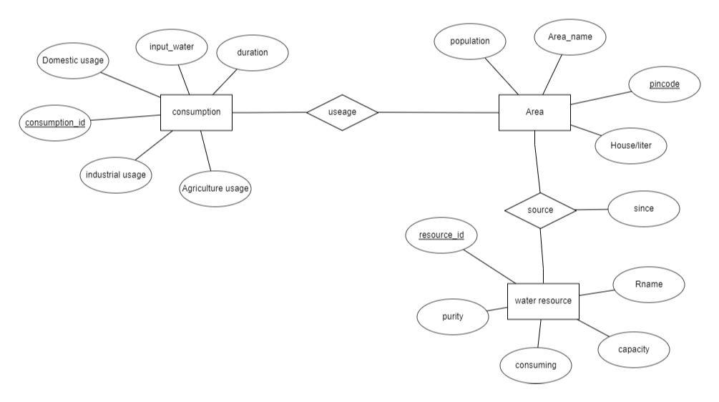

**DATABASE DESIGN**

**Mapping Cardinality and Participation Constraints**

* **In h2o tracking in particular area the amount of water is consumed and is calculated by h2o tracker . Here the relationship sets like source and usage related between area and consumption , area and water resource respective . There are different types of consumptions like agricultural usage , domestic usage and industrial usage in that area .**

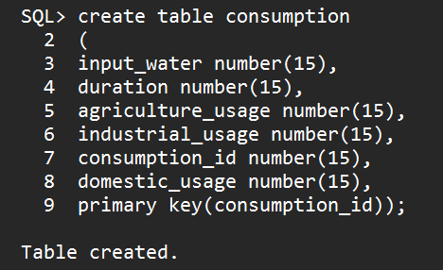

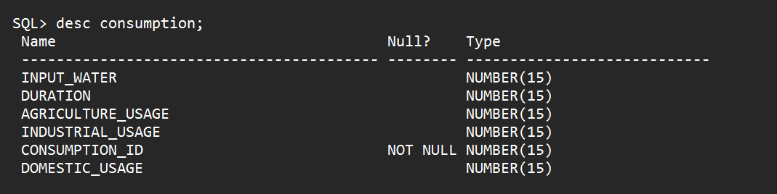

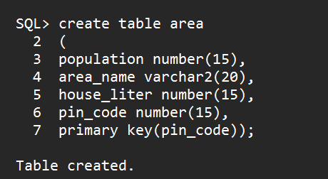

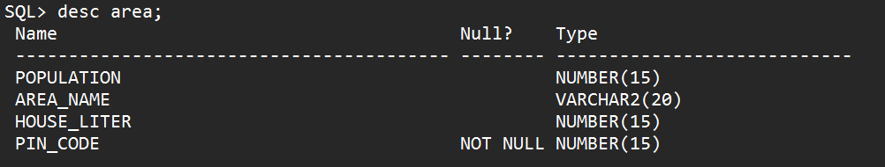

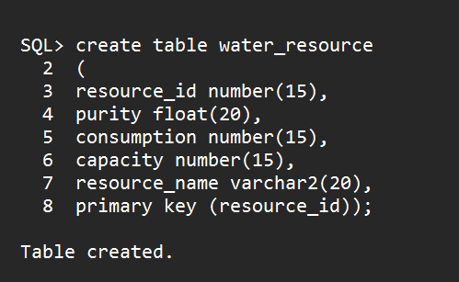

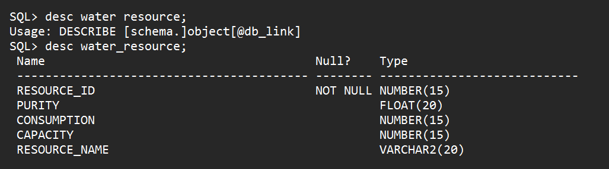

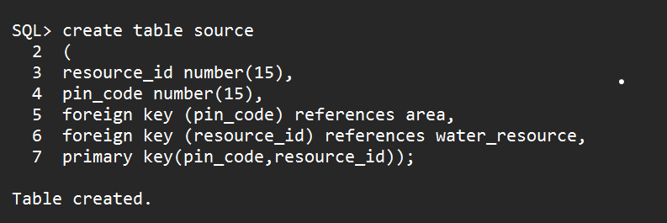

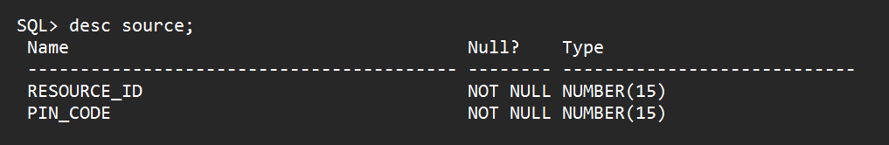

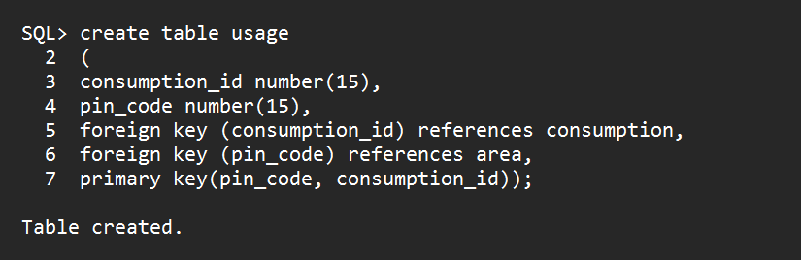

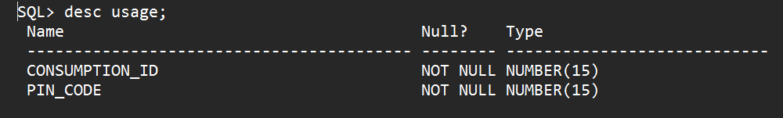

**DML Operations**

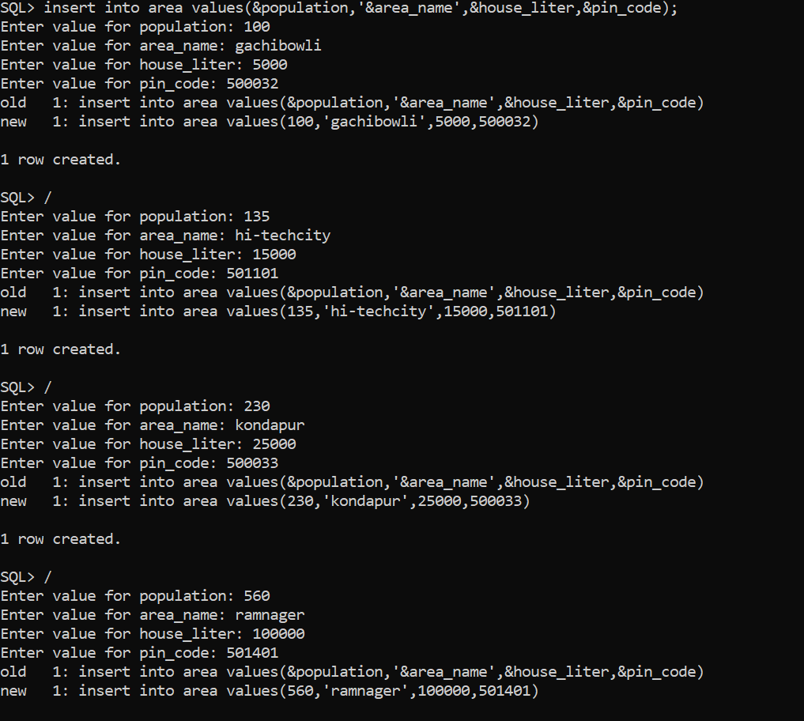

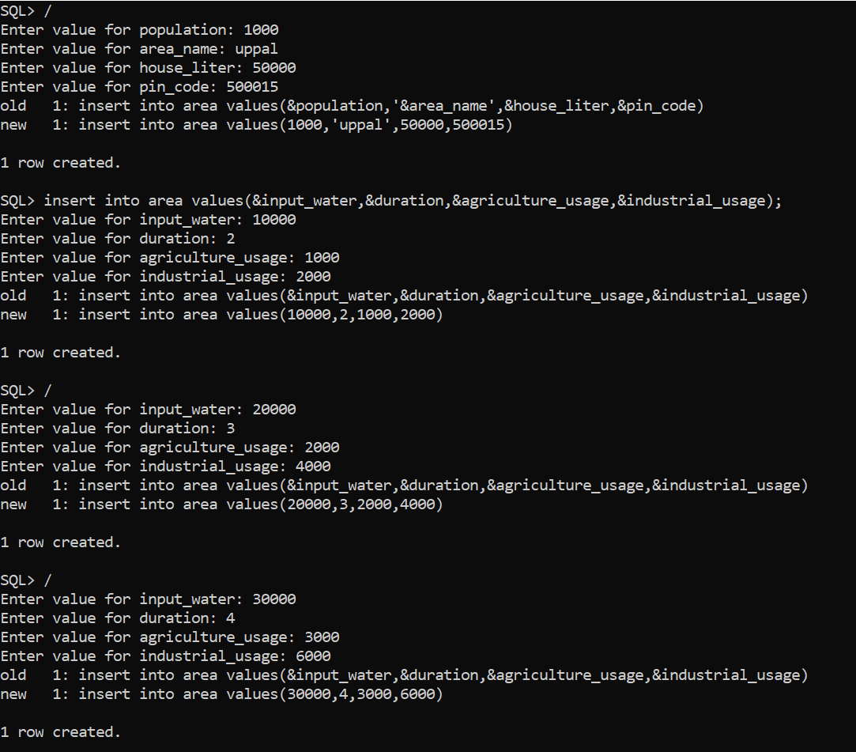

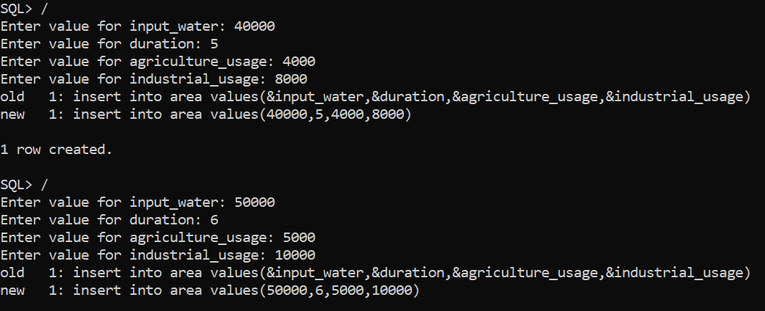

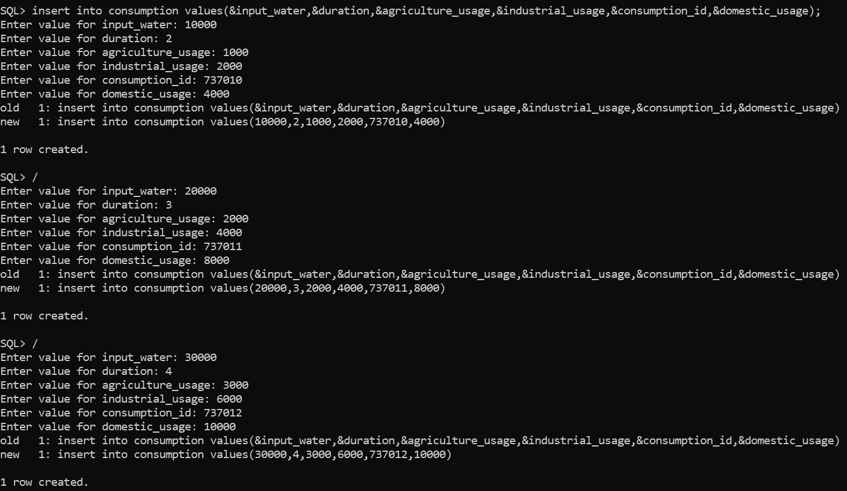

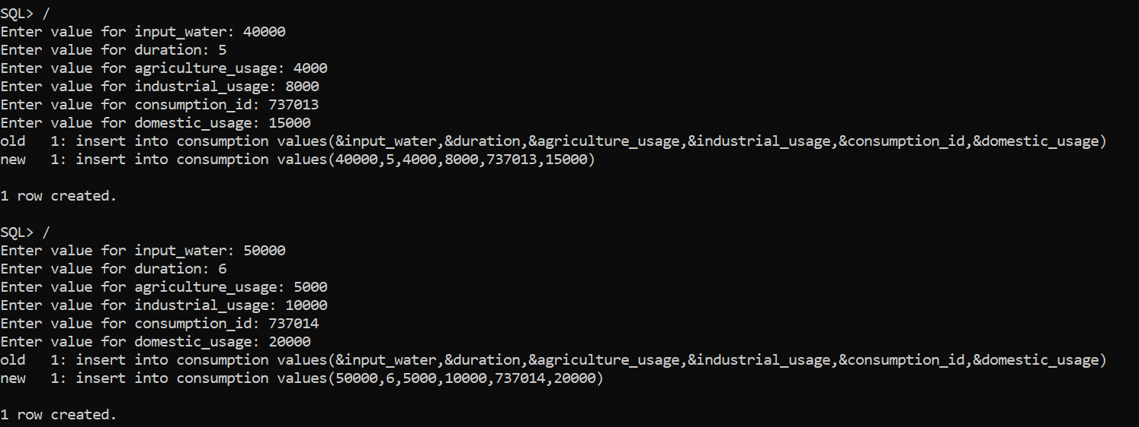

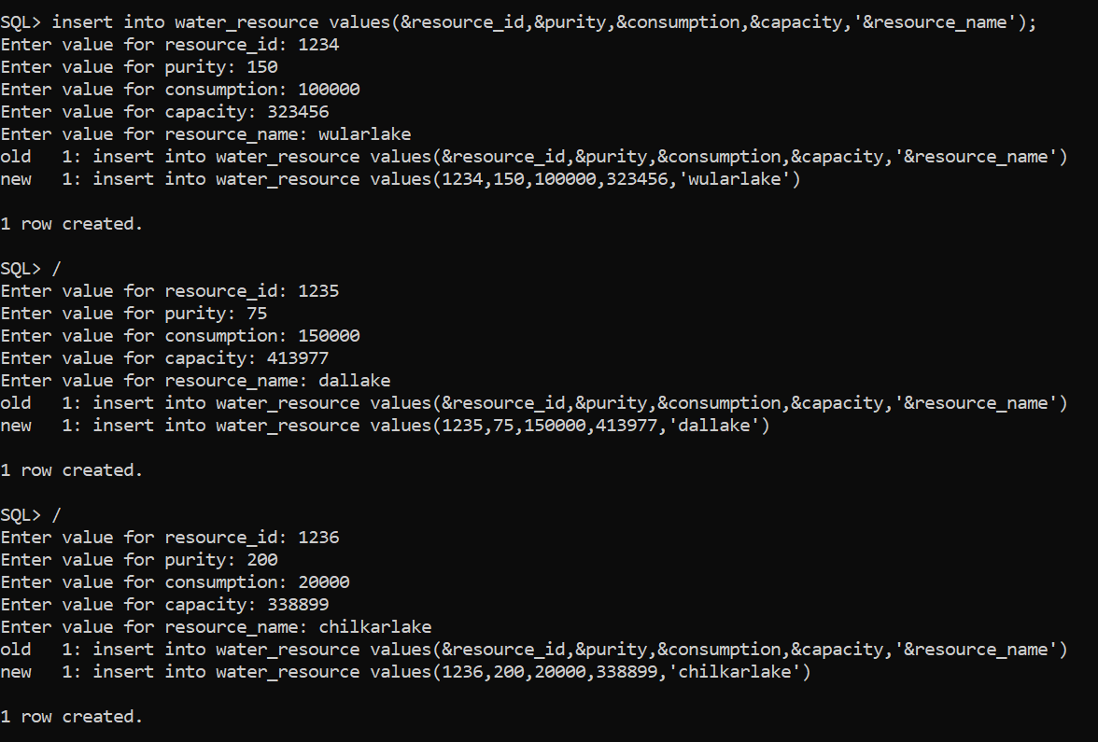

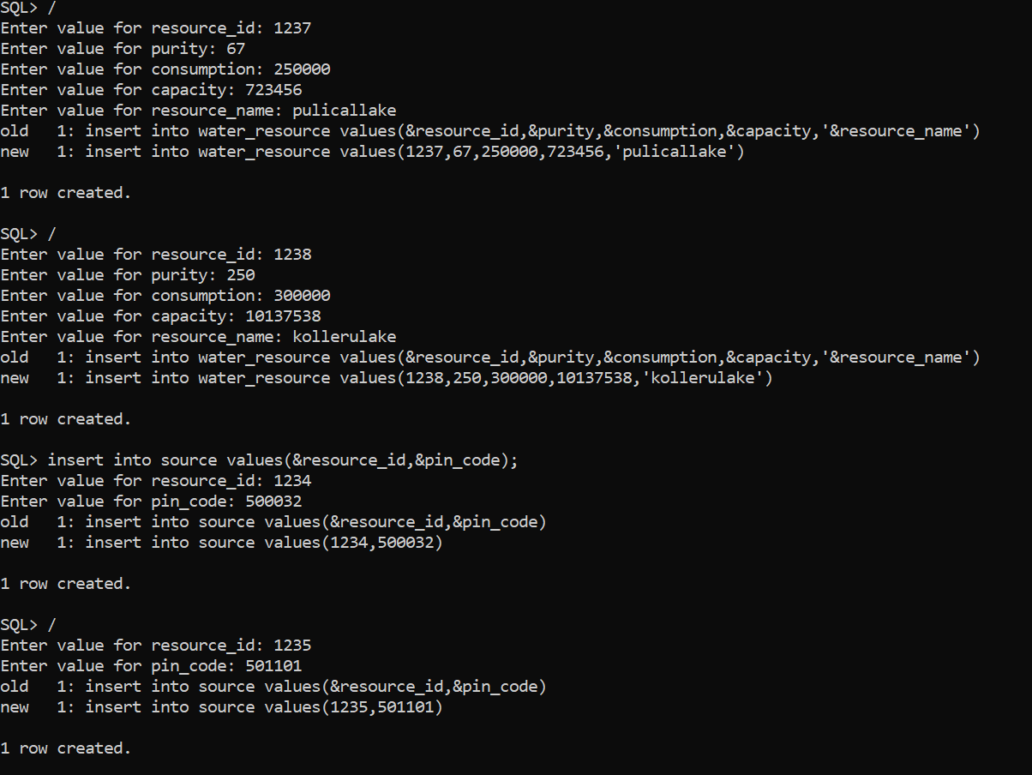

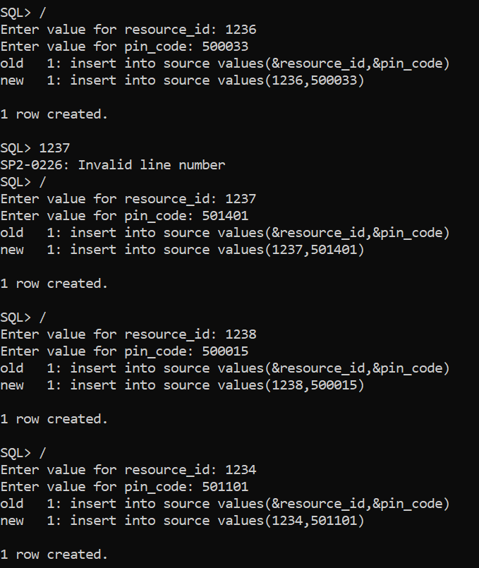

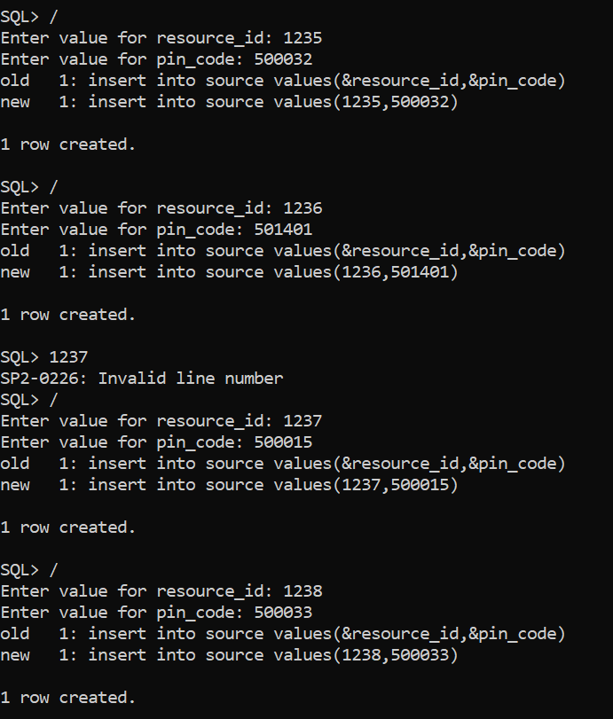

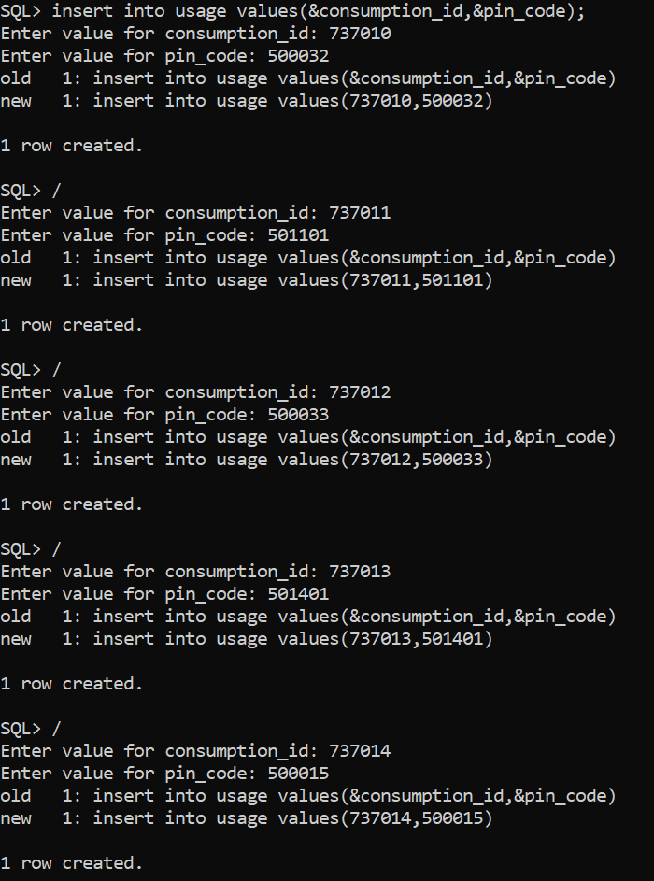

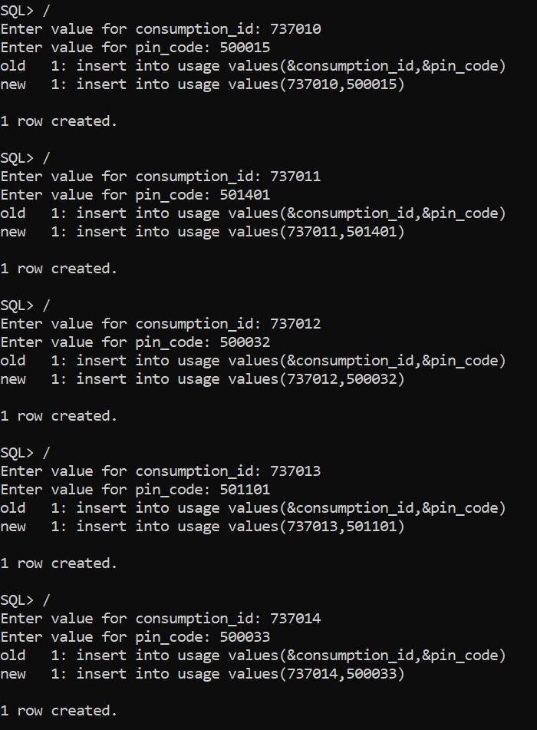

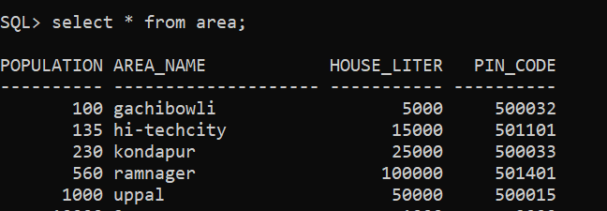

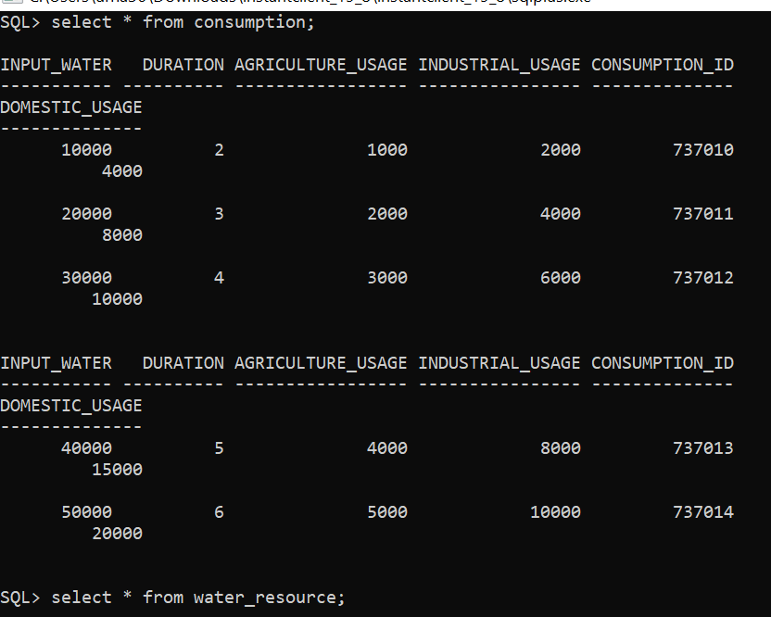

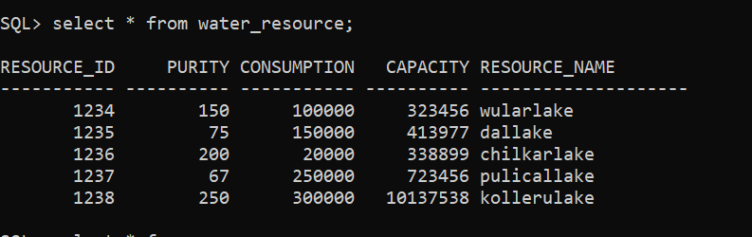

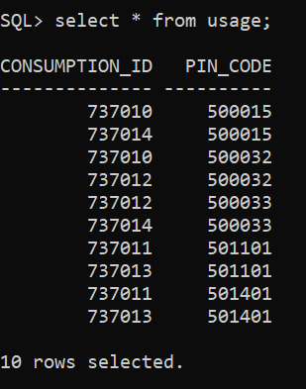

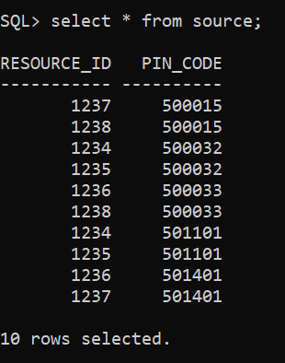

/*

* Click nbfs://nbhost/SystemFileSystem/Templates/Licenses/license-default.txt to change this license

* Click nbfs://nbhost/SystemFileSystem/Templates/GUIForms/JFrame.java to edit this template

*/

package com.mycompany.databaseconnectiondemo;

/**

*

*

*/

public class Main extends javax.swing.JFrame {

/**

* Creates new form Main

*/

public Main() {

initComponents();

}

/**

* This method is called from within the constructor to initialize the form.

* WARNING: Do NOT modify this code. The content of this method is always

* regenerated by the Form Editor.

*/

@SuppressWarnings("unchecked")

// <editor-fold defaultstate="collapsed" desc="Generated Code">

private void initComponents() {

jLabel1 = new javax.swing.JLabel();

jLabel2 = new javax.swing.JLabel();

jMenuBar1 = new javax.swing.JMenuBar();

jMenu2 = new javax.swing.JMenu();

jMenuItem3 = new javax.swing.JMenuItem();

jMenuItem4 = new javax.swing.JMenuItem();

jMenuItem5 = new javax.swing.JMenuItem();

jMenuItem6 = new javax.swing.JMenuItem();

jMenu1 = new javax.swing.JMenu();

jMenuItem1 = new javax.swing.JMenuItem();

jMenuItem2 = new javax.swing.JMenuItem();

jMenu3 = new javax.swing.JMenu();

setDefaultCloseOperation(javax.swing.WindowConstants.EXIT_ON_CLOSE);

jLabel2.setFont(new java.awt.Font("Segoe UI", 1, 48)); // NOI18N

jLabel2.setText("H2O TRACKER");

jMenu2.setText("Area");

jMenuItem3.setText("insert");

jMenuItem3.addActionListener(new java.awt.event.ActionListener() {

public void actionPerformed(java.awt.event.ActionEvent evt) {

jMenuItem3ActionPerformed(evt);

}

});

jMenu2.add(jMenuItem3);

jMenuItem4.setText("delete");

jMenu2.add(jMenuItem4);

jMenuItem5.setText("update");

jMenuItem5.addActionListener(new java.awt.event.ActionListener() {

public void actionPerformed(java.awt.event.ActionEvent evt) {

jMenuItem5ActionPerformed(evt);

}

});

jMenu2.add(jMenuItem5);

jMenuItem6.setText("view");

jMenu2.add(jMenuItem6);

jMenuBar1.add(jMenu2);

jMenu1.setText("consumption");

jMenuItem1.setText("insert");

jMenuItem1.addActionListener(new java.awt.event.ActionListener() {

public void actionPerformed(java.awt.event.ActionEvent evt) {

jMenuItem1ActionPerformed(evt);

}

});

jMenu1.add(jMenuItem1);

jMenuItem2.setText("delete");

jMenu1.add(jMenuItem2);

jMenuBar1.add(jMenu1);

jMenu3.setText("water_resource");

jMenuBar1.add(jMenu3);

setJMenuBar(jMenuBar1);

javax.swing.GroupLayout layout = new javax.swing.GroupLayout(getContentPane());

getContentPane().setLayout(layout);

layout.setHorizontalGroup(

layout.createParallelGroup(javax.swing.GroupLayout.Alignment.LEADING)

.addGroup(layout.createSequentialGroup()

.addGap(72, 72, 72)

.addComponent(jLabel1)

.addPreferredGap(javax.swing.LayoutStyle.ComponentPlacement.RELATED, 95, Short.MAX_VALUE)

.addComponent(jLabel2, javax.swing.GroupLayout.PREFERRED_SIZE, 378, javax.swing.GroupLayout.PREFERRED_SIZE)

.addGap(90, 90, 90))

);

layout.setVerticalGroup(

layout.createParallelGroup(javax.swing.GroupLayout.Alignment.LEADING)

.addGroup(layout.createSequentialGroup()

.addGroup(layout.createParallelGroup(javax.swing.GroupLayout.Alignment.LEADING)

.addGroup(layout.createSequentialGroup()

.addGap(68, 68, 68)

.addComponent(jLabel1))

.addGroup(layout.createSequentialGroup()

.addGap(19, 19, 19)

.addComponent(jLabel2, javax.swing.GroupLayout.PREFERRED_SIZE, 124, javax.swing.GroupLayout.PREFERRED_SIZE)))

.addContainerGap(232, Short.MAX_VALUE))

);

pack();

}// </editor-fold>

private void jMenuItem1ActionPerformed(java.awt.event.ActionEvent evt) {

new bill().setVisible(true); // TODO add your handling code here:

}

private void jMenuItem3ActionPerformed(java.awt.event.ActionEvent evt) {

// TODO add your handling code here:

}

private void jMenuItem5ActionPerformed(java.awt.event.ActionEvent evt) {

// TODO add your handling code here:

}

/**

* @param args the command line arguments

*/

public static void main(String args[]) {

/* Set the Nimbus look and feel */

//<editor-fold defaultstate="collapsed" desc=" Look and feel setting code (optional) ">

/* If Nimbus (introduced in Java SE 6) is not available, stay with the default look and feel.

* For details see http://download.oracle.com/javase/tutorial/uiswing/lookandfeel/plaf.html

*/

try {

for (javax.swing.UIManager.LookAndFeelInfo info : javax.swing.UIManager.getInstalledLookAndFeels()) {

if ("Nimbus".equals(info.getName())) {

javax.swing.UIManager.setLookAndFeel(info.getClassName());

break;

}

}

} catch (ClassNotFoundException | InstantiationException | IllegalAccessException | javax.swing.UnsupportedLookAndFeelException ex) {

java.util.logging.Logger.getLogger(Main.class.getName()).log(java.util.logging.Level.SEVERE, null, ex);

}

//</editor-fold>

//</editor-fold>

/* Create and display the form */

java.awt.EventQueue.invokeLater(() -> {

new Main().setVisible(true);

});

}

// Variables declaration - do not modify

private javax.swing.JLabel jLabel1;

private javax.swing.JLabel jLabel2;

private javax.swing.JMenu jMenu1;

private javax.swing.JMenu jMenu2;

private javax.swing.JMenu jMenu3;

private javax.swing.JMenuBar jMenuBar1;

private javax.swing.JMenuItem jMenuItem1;

private javax.swing.JMenuItem jMenuItem2;

private javax.swing.JMenuItem jMenuItem3;

private javax.swing.JMenuItem jMenuItem4;

private javax.swing.JMenuItem jMenuItem5;

private javax.swing.JMenuItem jMenuItem6;

// End of variables declaration

private static class bill {

public bill() {

}

private void setVisible(boolean b) {

throw new UnsupportedOperationException("Not supported yet."); // Generated from nbfs://nbhost/SystemFileSystem/Templates/Classes/Code/GeneratedMethodBody

}

}

}

AREA INSERT

**/\***

**\* Click nbfs://nbhost/SystemFileSystem/Templates/Licenses/license-default.txt to change this license**

**\* Click nbfs://nbhost/SystemFileSystem/Templates/GUIForms/JFrame.java to edit this template**

**\*/**

**package com.mycompany.databaseconnectiondemo;**

**/\*\***

**\***

**\***

**\*/**

**public class Bill extends javax.swing.JFrame {**

**/\*\***

**\* Creates new form Bill**

**\*/**

**public Bill() {**

**initComponents();**

**}**

**/\*\***

**\* This method is called from within the constructor to initialize the form.**

**\* WARNING: Do NOT modify this code. The content of this method is always**

**\* regenerated by the Form Editor.**

**\*/**

**@SuppressWarnings("unchecked")**

**// <editor-fold defaultstate="collapsed" desc="Generated Code">**

**private void initComponents() {**

**jLabel1 = new javax.swing.JLabel();**

**jLabel2 = new javax.swing.JLabel();**

**jTextField1 = new javax.swing.JTextField();**

**jLabel3 = new javax.swing.JLabel();**

**jTextField2 = new javax.swing.JTextField();**

**jLabel4 = new javax.swing.JLabel();**

**jTextField3 = new javax.swing.JTextField();**

**jLabel5 = new javax.swing.JLabel();**

**jTextField4 = new javax.swing.JTextField();**

**jButton1 = new javax.swing.JButton();**

**jButton2 = new javax.swing.JButton();**

**setDefaultCloseOperation(javax.swing.WindowConstants.EXIT_ON_CLOSE);**

**jLabel1.setText("Area");**

**jLabel2.setText("pincode");**

**jTextField1.setText("500032");**

**jTextField1.addActionListener(new java.awt.event.ActionListener() {**

**public void actionPerformed(java.awt.event.ActionEvent evt) {**

**jTextField1ActionPerformed(evt);**

**}**

**});**

**jLabel3.setText("area_name");**

**jTextField2.setText("GACHIBOWLI");**

**jTextField2.addActionListener(new java.awt.event.ActionListener() {**

**public void actionPerformed(java.awt.event.ActionEvent evt) {**

**jTextField2ActionPerformed(evt);**

**}**

**});**

**jLabel4.setText("population");**

**jTextField3.setText("100");**

**jTextField3.addActionListener(new java.awt.event.ActionListener() {**

**public void actionPerformed(java.awt.event.ActionEvent evt) {**

**jTextField3ActionPerformed(evt);**

**}**

**});**

**jLabel5.setText("house/liter");**

**jTextField4.setText("5000");**

**jTextField4.addActionListener(new java.awt.event.ActionListener() {**

**public void actionPerformed(java.awt.event.ActionEvent evt) {**

**jTextField4ActionPerformed(evt);**

**}**

**});**

**jButton1.setText("INSERT");**

**jButton1.addActionListener(new java.awt.event.ActionListener() {**

**public void actionPerformed(java.awt.event.ActionEvent evt) {**

**jButton1ActionPerformed(evt);**

**}**

**});**

**jButton2.setText("BACK");**

**jButton2.addActionListener(new java.awt.event.ActionListener() {**

**public void actionPerformed(java.awt.event.ActionEvent evt) {**

**jButton2ActionPerformed(evt);**

**}**

**});**

**javax.swing.GroupLayout layout = new javax.swing.GroupLayout(getContentPane());**

**getContentPane().setLayout(layout);**

**layout.setHorizontalGroup(**

**layout.createParallelGroup(javax.swing.GroupLayout.Alignment.LEADING)**

**.addGroup(layout.createSequentialGroup()**

**.addGroup(layout.createParallelGroup(javax.swing.GroupLayout.Alignment.LEADING)**

**.addGroup(layout.createSequentialGroup()**

**.addGap(26, 26, 26)**

**.addGroup(layout.createParallelGroup(javax.swing.GroupLayout.Alignment.LEADING, false)**

**.addComponent(jLabel4, javax.swing.GroupLayout.DEFAULT_SIZE, javax.swing.GroupLayout.DEFAULT_SIZE, Short.MAX_VALUE)**

**.addComponent(jLabel2, javax.swing.GroupLayout.PREFERRED_SIZE, 103, javax.swing.GroupLayout.PREFERRED_SIZE)**

**.addComponent(jLabel5, javax.swing.GroupLayout.DEFAULT_SIZE, javax.swing.GroupLayout.DEFAULT_SIZE, Short.MAX_VALUE)**

**.addComponent(jLabel3))**

**.addGap(91, 91, 91)**

**.addGroup(layout.createParallelGroup(javax.swing.GroupLayout.Alignment.LEADING, false)**

**.addComponent(jTextField1)**

**.addComponent(jTextField2)**

**.addComponent(jTextField4)**

**.addComponent(jTextField3, javax.swing.GroupLayout.Alignment.TRAILING, javax.swing.GroupLayout.PREFERRED_SIZE, 255, javax.swing.GroupLayout.PREFERRED_SIZE)))**

**.addGroup(layout.createSequentialGroup()**

**.addGap(113, 113, 113)**

**.addComponent(jButton1)**

**.addGap(75, 75, 75)**

**.addComponent(jButton2))**

**.addGroup(layout.createSequentialGroup()**

**.addGap(206, 206, 206)**

**.addComponent(jLabel1, javax.swing.GroupLayout.PREFERRED_SIZE, 120, javax.swing.GroupLayout.PREFERRED_SIZE)))**

**.addContainerGap(84, Short.MAX_VALUE))**

**);**

**layout.setVerticalGroup(**

**layout.createParallelGroup(javax.swing.GroupLayout.Alignment.LEADING)**

**.addGroup(layout.createSequentialGroup()**

**.addContainerGap(javax.swing.GroupLayout.DEFAULT_SIZE, Short.MAX_VALUE)**

**.addComponent(jLabel1, javax.swing.GroupLayout.PREFERRED_SIZE, 51, javax.swing.GroupLayout.PREFERRED_SIZE)**

**.addGap(18, 18, 18)**

**.addGroup(layout.createParallelGroup(javax.swing.GroupLayout.Alignment.LEADING)**

**.addGroup(layout.createSequentialGroup()**

**.addGroup(layout.createParallelGroup(javax.swing.GroupLayout.Alignment.BASELINE)**

**.addComponent(jLabel2, javax.swing.GroupLayout.PREFERRED_SIZE, 48, javax.swing.GroupLayout.PREFERRED_SIZE)**

**.addComponent(jTextField1, javax.swing.GroupLayout.PREFERRED_SIZE, javax.swing.GroupLayout.DEFAULT_SIZE, javax.swing.GroupLayout.PREFERRED_SIZE))**

**.addGap(23, 23, 23)**

**.addGroup(layout.createParallelGroup(javax.swing.GroupLayout.Alignment.TRAILING)**

**.addComponent(jTextField2, javax.swing.GroupLayout.PREFERRED_SIZE, javax.swing.GroupLayout.DEFAULT_SIZE, javax.swing.GroupLayout.PREFERRED_SIZE)**

**.addComponent(jLabel3))**

**.addGap(24, 24, 24)**

**.addGroup(layout.createParallelGroup(javax.swing.GroupLayout.Alignment.BASELINE)**

**.addComponent(jLabel4)**

**.addComponent(jTextField3, javax.swing.GroupLayout.PREFERRED_SIZE, javax.swing.GroupLayout.DEFAULT_SIZE, javax.swing.GroupLayout.PREFERRED_SIZE))**

**.addGap(27, 27, 27)**

**.addGroup(layout.createParallelGroup(javax.swing.GroupLayout.Alignment.BASELINE)**

**.addComponent(jLabel5, javax.swing.GroupLayout.PREFERRED_SIZE, 35, javax.swing.GroupLayout.PREFERRED_SIZE)**

**.addComponent(jTextField4, javax.swing.GroupLayout.PREFERRED_SIZE, javax.swing.GroupLayout.DEFAULT_SIZE, javax.swing.GroupLayout.PREFERRED_SIZE))**

**.addContainerGap(javax.swing.GroupLayout.DEFAULT_SIZE, Short.MAX_VALUE))**

**.addGroup(javax.swing.GroupLayout.Alignment.TRAILING, layout.createSequentialGroup()**

**.addGap(302, 302, 302)**

**.addGroup(layout.createParallelGroup(javax.swing.GroupLayout.Alignment.BASELINE)**

**.addComponent(jButton2)**

**.addComponent(jButton1))**

**.addGap(48, 48, 48))))**

**);**

**pack();**

**}// </editor-fold>**

**private void jTextField1ActionPerformed(java.awt.event.ActionEvent evt) {**

**// TODO add your handling code here:**

**}**

**private void jTextField2ActionPerformed(java.awt.event.ActionEvent evt) {**

**// TODO add your handling code here:**

**}**

**private void jTextField4ActionPerformed(java.awt.event.ActionEvent evt) {**

**// TODO add your handling code here:**

**}**

**private void jButton1ActionPerformed(java.awt.event.ActionEvent evt) {**

**// TODO add your handling code here:**

**}**

**private void jTextField3ActionPerformed(java.awt.event.ActionEvent evt) {**

**// TODO add your handling code here:**

**}**

**private void jButton2ActionPerformed(java.awt.event.ActionEvent evt) {**

**// TODO add your handling code here:**

**}**

**/\*\***

**\* @param args the command line arguments**

**\*/**

**public static void main(String args[]) {**

**/* Set the Nimbus look and feel */**

**//<editor-fold defaultstate="collapsed" desc=" Look and feel setting code (optional) ">**

**/* If Nimbus (introduced in Java SE 6) is not available, stay with the default look and feel.**

**\* For details see http://download.oracle.com/javase/tutorial/uiswing/lookandfeel/plaf.html**

**\*/**

**try {**

**for (javax.swing.UIManager.LookAndFeelInfo info : javax.swing.UIManager.getInstalledLookAndFeels()) {**

**if ("Nimbus".equals(info.getName())) {**

**javax.swing.UIManager.setLookAndFeel(info.getClassName());**

**break;**

**}**

**}**

**} catch (ClassNotFoundException ex) {**

**java.util.logging.Logger.getLogger(Bill.class.getName()).log(java.util.logging.Level.SEVERE, null, ex);**

**} catch (InstantiationException ex) {**

**java.util.logging.Logger.getLogger(Bill.class.getName()).log(java.util.logging.Level.SEVERE, null, ex);**

**} catch (IllegalAccessException ex) {**

**java.util.logging.Logger.getLogger(Bill.class.getName()).log(java.util.logging.Level.SEVERE, null, ex);**

**} catch (javax.swing.UnsupportedLookAndFeelException ex) {**

**java.util.logging.Logger.getLogger(Bill.class.getName()).log(java.util.logging.Level.SEVERE, null, ex);**

**}**

**//</editor-fold>**

**/* Create and display the form */**

**java.awt.EventQueue.invokeLater(new Runnable() {**

**public void run() {**

**new Bill().setVisible(true);**

**}**

**});**

**}**

**// Variables declaration - do not modify**

**private javax.swing.JButton jButton1;**

**private javax.swing.JButton jButton2;**

**private javax.swing.JLabel jLabel1;**

**private javax.swing.JLabel jLabel2;**

**private javax.swing.JLabel jLabel3;**

**private javax.swing.JLabel jLabel4;**

**private javax.swing.JLabel jLabel5;**

**private javax.swing.JTextField jTextField1;**

**private javax.swing.JTextField jTextField2;**

**private javax.swing.JTextField jTextField3;**

**private javax.swing.JTextField jTextField4;**

**// End of variables declaration**

**}**

**VIEW**

**/\***

**\* Click nbfs://nbhost/SystemFileSystem/Templates/Licenses/license-default.txt to change this license**

**\* Click nbfs://nbhost/SystemFileSystem/Templates/GUIForms/JFrame.java to edit this template**

**\*/**

**package com.mycompany.databaseconnectiondemo;**

**import java.sql.Connection;**

**import java.sql.DriverManager;**

**import java.sql.Statement;**

**import javax.swing.table.DefaultTableModel;**

**/\*\***

**\***

**\***

**\*/**

**public class MyFrame extends javax.swing.JFrame {**

**/\*\***

**\* Creates new form MyFrame**

**\*/**

**public MyFrame() {**

**//**

**initComponents();**

**}**

**/\*\***

**\* This method is called from within the constructor to initialize the form.**

**\* WARNING: Do NOT modify this code. The content of this method is always**

**\* regenerated by the Form Editor.**

**\*/**

**@SuppressWarnings("unchecked")**

**// <editor-fold defaultstate="collapsed" desc="Generated Code">**

**private void initComponents() {**

**jScrollPane1 = new javax.swing.JScrollPane();**

**jTable1 = new javax.swing.JTable();**

**jButton1 = new javax.swing.JButton();**

**setDefaultCloseOperation(javax.swing.WindowConstants.EXIT_ON_CLOSE);**

**jTable1.setModel(new javax.swing.table.DefaultTableModel(**

**new Object [][] {**

**{null, null, null, null},**

**{null, null, null, null},**

**{null, null, null, null},**

**{null, null, null, null}**

**},**

**new String [] {**

**"PIN_CODE", "AREA_NAME", "POPULATION", "HOUSE/LITER"**

**}**

**));**

**jScrollPane1.setViewportView(jTable1);**

**jButton1.setText("VIEW");**

**jButton1.addActionListener(new java.awt.event.ActionListener() {**

**public void actionPerformed(java.awt.event.ActionEvent evt) {**

**jButton1ActionPerformed(evt);**

**}**

**});**

**javax.swing.GroupLayout layout = new javax.swing.GroupLayout(getContentPane());**

**getContentPane().setLayout(layout);**

**layout.setHorizontalGroup(**

**layout.createParallelGroup(javax.swing.GroupLayout.Alignment.LEADING)**

**.addGroup(layout.createSequentialGroup()**

**.addGap(229, 229, 229)**

**.addComponent(jButton1)**

**.addContainerGap(261, Short.MAX_VALUE))**

**.addGroup(layout.createParallelGroup(javax.swing.GroupLayout.Alignment.LEADING)**

**.addGroup(javax.swing.GroupLayout.Alignment.TRAILING, layout.createSequentialGroup()**

**.addContainerGap(49, Short.MAX_VALUE)**

**.addComponent(jScrollPane1, javax.swing.GroupLayout.PREFERRED_SIZE, 498, javax.swing.GroupLayout.PREFERRED_SIZE)**

**.addContainerGap(51, Short.MAX_VALUE)))**

**);**

**layout.setVerticalGroup(**

**layout.createParallelGroup(javax.swing.GroupLayout.Alignment.LEADING)**

**.addGroup(layout.createSequentialGroup()**

**.addGap(54, 54, 54)**

**.addComponent(jButton1)**

**.addContainerGap(399, Short.MAX_VALUE))**

**.addGroup(layout.createParallelGroup(javax.swing.GroupLayout.Alignment.LEADING)**

**.addGroup(javax.swing.GroupLayout.Alignment.TRAILING, layout.createSequentialGroup()**

**.addContainerGap(128, Short.MAX_VALUE)**

**.addComponent(jScrollPane1, javax.swing.GroupLayout.PREFERRED_SIZE, 253, javax.swing.GroupLayout.PREFERRED_SIZE)**

**.addContainerGap(107, Short.MAX_VALUE)))**

**);**

**pack();**

**}// </editor-fold>**

**private void jButton1ActionPerformed(java.awt.event.ActionEvent evt) {**

**try**

**{**

**// Load Oracle JDBC Driver**

**Class.forName("oracle.jdbc.OracleDriver");**

**Connection con=DriverManager.getConnection("jdbc:oracle:thin:@218.248.0.7:1521:rdbms","it20737010","vasavi");**

**Statement statement = (Statement) con.createStatement();**

**// Execute a SELECT query on Oracle Dummy DUAL Table. Useful for retrieving system values**

**// Enables us to retrieve values as if querying from a table**

**String query= "select * from AREA";**

**//String sqlqry="insert into customers values()"**

**java.sql.ResultSet rs = statement.executeQuery(query);**

**DefaultTableModel model = (DefaultTableModel)jTable1.getModel();**

**while(rs.next()){**

**model.addRow(new Object[]{rs.getString("pin_code"), rs.getString("area_name"),rs.getString("house_liter"),rs.getString("population")});**

**}**

**System .out.println("Retrived ....");**

**rs.close();**

**statement.close();**

**con.close();**

**}**

**catch(Exception e)**

**{**

**System.out.println(e);**

**}**

**// TODO add your handling code here:**

**}**

**/\*\***

**\* @param args the command line arguments**

**\*/**

**public static void main(String args[]) {**

**/* Set the Nimbus look and feel */**

**//<editor-fold defaultstate="collapsed" desc=" Look and feel setting code (optional) ">**

**/* If Nimbus (introduced in Java SE 6) is not available, stay with the default look and feel.**

**\* For details see http://download.oracle.com/javase/tutorial/uiswing/lookandfeel/plaf.html**

**\*/**

**try {**

**for (javax.swing.UIManager.LookAndFeelInfo info : javax.swing.UIManager.getInstalledLookAndFeels()) {**

**if ("Nimbus".equals(info.getName())) {**

**javax.swing.UIManager.setLookAndFeel(info.getClassName());**

**break;**

**}**

**}**

**} catch (ClassNotFoundException ex) {**

**java.util.logging.Logger.getLogger(MyFrame.class.getName()).log(java.util.logging.Level.SEVERE, null, ex);**

**} catch (InstantiationException ex) {**

**java.util.logging.Logger.getLogger(MyFrame.class.getName()).log(java.util.logging.Level.SEVERE, null, ex);**

**} catch (IllegalAccessException ex) {**

**java.util.logging.Logger.getLogger(MyFrame.class.getName()).log(java.util.logging.Level.SEVERE, null, ex);**

**} catch (javax.swing.UnsupportedLookAndFeelException ex) {**

**java.util.logging.Logger.getLogger(MyFrame.class.getName()).log(java.util.logging.Level.SEVERE, null, ex);**

**}**

**//</editor-fold>**

**/* Create and display the form */**

**java.awt.EventQueue.invokeLater(new Runnable() {**

**public void run() {**

**new MyFrame().setVisible(true);**

**}**

**});**

**}**

**// Variables declaration - do not modify**

**private javax.swing.JButton jButton1;**

**private javax.swing.JScrollPane jScrollPane1;**

**private javax.swing.JTable jTable1;**

**// End of variables declaration**

**}**

VIEW UPDATE

/*

* Click nbfs://nbhost/SystemFileSystem/Templates/Licenses/license-default.txt to change this license

* Click nbfs://nbhost/SystemFileSystem/Templates/GUIForms/JFrame.java to edit this template

*/

package com.mycompany.databaseconnectiondemo;

/**

*

* @author uma36

*/

public class bill_delete extends javax.swing.JFrame {

/**

* Creates new form bill_delete

*/

public bill_delete() {

initComponents();

}

/**

* This method is called from within the constructor to initialize the form.

* WARNING: Do NOT modify this code. The content of this method is always

* regenerated by the Form Editor.

*/

@SuppressWarnings("unchecked")

// <editor-fold defaultstate="collapsed" desc="Generated Code">

private void initComponents() {

jLabel1 = new javax.swing.JLabel();

jLabel2 = new javax.swing.JLabel();

jTextField1 = new javax.swing.JTextField();

jButton1 = new javax.swing.JButton();

jLabel3 = new javax.swing.JLabel();

jLabel4 = new javax.swing.JLabel();

jLabel6 = new javax.swing.JLabel();

jLabel8 = new javax.swing.JLabel();

jButton2 = new javax.swing.JButton();

jTextField2 = new javax.swing.JTextField();

jTextField3 = new javax.swing.JTextField();

jTextField4 = new javax.swing.JTextField();

setDefaultCloseOperation(javax.swing.WindowConstants.EXIT_ON_CLOSE);

jLabel1.setText("AREA_UPDATE");

jLabel2.setText("PIN_ID");

jTextField1.addActionListener(new java.awt.event.ActionListener() {

public void actionPerformed(java.awt.event.ActionEvent evt) {

jTextField1ActionPerformed(evt);

}

});

jButton1.setText("UPDATE");

jButton1.addActionListener(new java.awt.event.ActionListener() {

public void actionPerformed(java.awt.event.ActionEvent evt) {

jButton1ActionPerformed(evt);

}

});

jLabel3.setText("AREA_NAME");

jLabel6.setText("POPULATION");

jLabel8.setText("HOUSE/LITER");

jButton2.setText("BACK");

jButton2.addActionListener(new java.awt.event.ActionListener() {

public void actionPerformed(java.awt.event.ActionEvent evt) {

jButton2ActionPerformed(evt);

}

});

jTextField2.addActionListener(new java.awt.event.ActionListener() {

public void actionPerformed(java.awt.event.ActionEvent evt) {

jTextField2ActionPerformed(evt);

}

});

jTextField3.addActionListener(new java.awt.event.ActionListener() {

public void actionPerformed(java.awt.event.ActionEvent evt) {

jTextField3ActionPerformed(evt);

}

});

jTextField4.addActionListener(new java.awt.event.ActionListener() {

public void actionPerformed(java.awt.event.ActionEvent evt) {

jTextField4ActionPerformed(evt);

}

});

javax.swing.GroupLayout layout = new javax.swing.GroupLayout(getContentPane());

getContentPane().setLayout(layout);

layout.setHorizontalGroup(

layout.createParallelGroup(javax.swing.GroupLayout.Alignment.LEADING)

.addGroup(layout.createSequentialGroup()

.addGroup(layout.createParallelGroup(javax.swing.GroupLayout.Alignment.LEADING)

.addGroup(layout.createSequentialGroup()

.addGap(145, 145, 145)

.addComponent(jLabel1, javax.swing.GroupLayout.PREFERRED_SIZE, 125, javax.swing.GroupLayout.PREFERRED_SIZE))

.addGroup(layout.createSequentialGroup()

.addGroup(layout.createParallelGroup(javax.swing.GroupLayout.Alignment.LEADING)

.addGroup(layout.createSequentialGroup()

.addGap(60, 60, 60)

.addComponent(jLabel3, javax.swing.GroupLayout.PREFERRED_SIZE, 128, javax.swing.GroupLayout.PREFERRED_SIZE)

.addGap(72, 72, 72)

.addComponent(jLabel4))

.addGroup(layout.createSequentialGroup()

.addGap(71, 71, 71)

.addComponent(jButton1)))

.addGroup(layout.createParallelGroup(javax.swing.GroupLayout.Alignment.LEADING)

.addGroup(layout.createParallelGroup(javax.swing.GroupLayout.Alignment.TRAILING)

.addGroup(layout.createSequentialGroup()

.addGap(45, 45, 45)

.addComponent(jButton2))

.addGroup(javax.swing.GroupLayout.Alignment.LEADING, layout.createSequentialGroup()

.addGap(18, 18, 18)

.addGroup(layout.createParallelGroup(javax.swing.GroupLayout.Alignment.LEADING)

.addComponent(jTextField2, javax.swing.GroupLayout.PREFERRED_SIZE, 205, javax.swing.GroupLayout.PREFERRED_SIZE)

.addGroup(layout.createParallelGroup(javax.swing.GroupLayout.Alignment.TRAILING)

.addComponent(jTextField3, javax.swing.GroupLayout.PREFERRED_SIZE, 161, javax.swing.GroupLayout.PREFERRED_SIZE)

.addComponent(jTextField4, javax.swing.GroupLayout.PREFERRED_SIZE, 164, javax.swing.GroupLayout.PREFERRED_SIZE)))))

.addGroup(layout.createSequentialGroup()

.addGap(18, 18, 18)

.addComponent(jTextField1, javax.swing.GroupLayout.PREFERRED_SIZE, 218, javax.swing.GroupLayout.PREFERRED_SIZE))))

.addGroup(layout.createSequentialGroup()

.addGap(52, 52, 52)

.addGroup(layout.createParallelGroup(javax.swing.GroupLayout.Alignment.LEADING)

.addComponent(jLabel2)

.addComponent(jLabel8, javax.swing.GroupLayout.PREFERRED_SIZE, 145, javax.swing.GroupLayout.PREFERRED_SIZE)

.addComponent(jLabel6, javax.swing.GroupLayout.PREFERRED_SIZE, 113, javax.swing.GroupLayout.PREFERRED_SIZE))))

.addContainerGap(182, Short.MAX_VALUE))

);

layout.setVerticalGroup(

layout.createParallelGroup(javax.swing.GroupLayout.Alignment.LEADING)

.addGroup(layout.createSequentialGroup()

.addGap(14, 14, 14)

.addComponent(jLabel1, javax.swing.GroupLayout.PREFERRED_SIZE, 48, javax.swing.GroupLayout.PREFERRED_SIZE)

.addGap(23, 23, 23)

.addGroup(layout.createParallelGroup(javax.swing.GroupLayout.Alignment.LEADING)

.addGroup(javax.swing.GroupLayout.Alignment.TRAILING, layout.createSequentialGroup()

.addGroup(layout.createParallelGroup(javax.swing.GroupLayout.Alignment.BASELINE)

.addComponent(jLabel2)

.addComponent(jTextField1, javax.swing.GroupLayout.PREFERRED_SIZE, javax.swing.GroupLayout.DEFAULT_SIZE, javax.swing.GroupLayout.PREFERRED_SIZE))

.addGap(66, 66, 66)

.addComponent(jLabel4)

.addGap(29, 29, 29))

.addGroup(javax.swing.GroupLayout.Alignment.TRAILING, layout.createParallelGroup(javax.swing.GroupLayout.Alignment.LEADING)

.addComponent(jTextField2, javax.swing.GroupLayout.PREFERRED_SIZE, javax.swing.GroupLayout.DEFAULT_SIZE, javax.swing.GroupLayout.PREFERRED_SIZE)

.addComponent(jLabel3, javax.swing.GroupLayout.PREFERRED_SIZE, 38, javax.swing.GroupLayout.PREFERRED_SIZE)))

.addComponent(jTextField4, javax.swing.GroupLayout.PREFERRED_SIZE, javax.swing.GroupLayout.DEFAULT_SIZE, javax.swing.GroupLayout.PREFERRED_SIZE)

.addPreferredGap(javax.swing.LayoutStyle.ComponentPlacement.RELATED)

.addComponent(jLabel6, javax.swing.GroupLayout.PREFERRED_SIZE, 31, javax.swing.GroupLayout.PREFERRED_SIZE)

.addGroup(layout.createParallelGroup(javax.swing.GroupLayout.Alignment.LEADING)

.addGroup(layout.createSequentialGroup()

.addGap(22, 22, 22)

.addComponent(jLabel8, javax.swing.GroupLayout.PREFERRED_SIZE, 31, javax.swing.GroupLayout.PREFERRED_SIZE))

.addGroup(layout.createSequentialGroup()

.addPreferredGap(javax.swing.LayoutStyle.ComponentPlacement.RELATED)

.addComponent(jTextField3, javax.swing.GroupLayout.PREFERRED_SIZE, javax.swing.GroupLayout.DEFAULT_SIZE, javax.swing.GroupLayout.PREFERRED_SIZE)))

.addPreferredGap(javax.swing.LayoutStyle.ComponentPlacement.RELATED, 25, Short.MAX_VALUE)

.addGroup(layout.createParallelGroup(javax.swing.GroupLayout.Alignment.BASELINE)

.addComponent(jButton1)

.addComponent(jButton2))

.addGap(72, 72, 72))

);

pack();

}// </editor-fold>

private void jTextField1ActionPerformed(java.awt.event.ActionEvent evt) {

// TODO add your handling code here:

}

private void jButton1ActionPerformed(java.awt.event.ActionEvent evt) {

// TODO add your handling code here:

}

private void jButton2ActionPerformed(java.awt.event.ActionEvent evt) {

// TODO add your handling code here:

}

private void jTextField2ActionPerformed(java.awt.event.ActionEvent evt) {

// TODO add your handling code here:

}

private void jTextField3ActionPerformed(java.awt.event.ActionEvent evt) {

// TODO add your handling code here:

}

private void jTextField4ActionPerformed(java.awt.event.ActionEvent evt) {

// TODO add your handling code here:

}

/**

* @param args the command line arguments

*/

public static void main(String args[]) {

/* Set the Nimbus look and feel */

//<editor-fold defaultstate="collapsed" desc=" Look and feel setting code (optional) ">

/* If Nimbus (introduced in Java SE 6) is not available, stay with the default look and feel.

* For details see http://download.oracle.com/javase/tutorial/uiswing/lookandfeel/plaf.html

*/

try {

for (javax.swing.UIManager.LookAndFeelInfo info : javax.swing.UIManager.getInstalledLookAndFeels()) {

if ("Nimbus".equals(info.getName())) {

javax.swing.UIManager.setLookAndFeel(info.getClassName());

break;

}

}

} catch (ClassNotFoundException ex) {

java.util.logging.Logger.getLogger(bill_delete.class.getName()).log(java.util.logging.Level.SEVERE, null, ex);

} catch (InstantiationException ex) {

java.util.logging.Logger.getLogger(bill_delete.class.getName()).log(java.util.logging.Level.SEVERE, null, ex);

} catch (IllegalAccessException ex) {

java.util.logging.Logger.getLogger(bill_delete.class.getName()).log(java.util.logging.Level.SEVERE, null, ex);

} catch (javax.swing.UnsupportedLookAndFeelException ex) {

java.util.logging.Logger.getLogger(bill_delete.class.getName()).log(java.util.logging.Level.SEVERE, null, ex);

}

//</editor-fold>

/* Create and display the form */

java.awt.EventQueue.invokeLater(new Runnable() {

public void run() {

new bill_delete().setVisible(true);

}

});

}

// Variables declaration - do not modify

private javax.swing.JButton jButton1;

private javax.swing.JButton jButton2;

private javax.swing.JLabel jLabel1;

private javax.swing.JLabel jLabel2;

private javax.swing.JLabel jLabel3;

private javax.swing.JLabel jLabel4;

private javax.swing.JLabel jLabel6;

private javax.swing.JLabel jLabel8;

private javax.swing.JTextField jTextField1;

private javax.swing.JTextField jTextField2;

private javax.swing.JTextField jTextField3;

private javax.swing.JTextField jTextField4;

// End of variables declaration

}

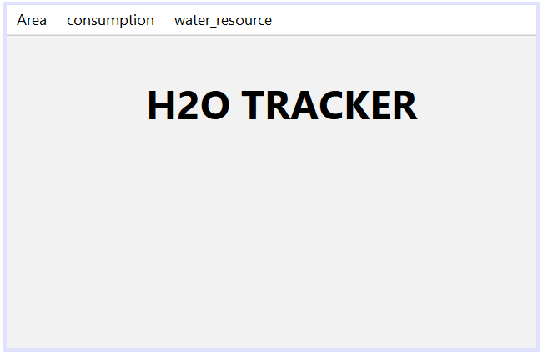

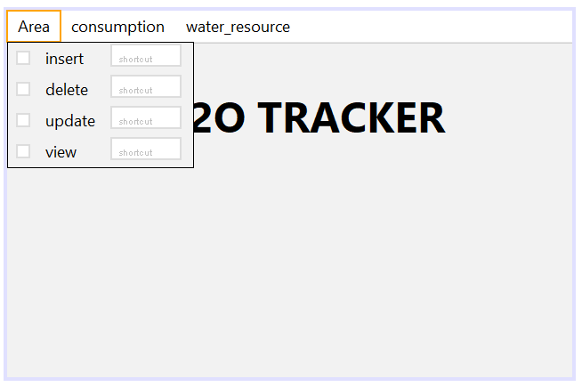

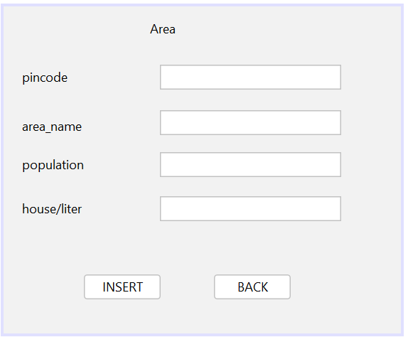

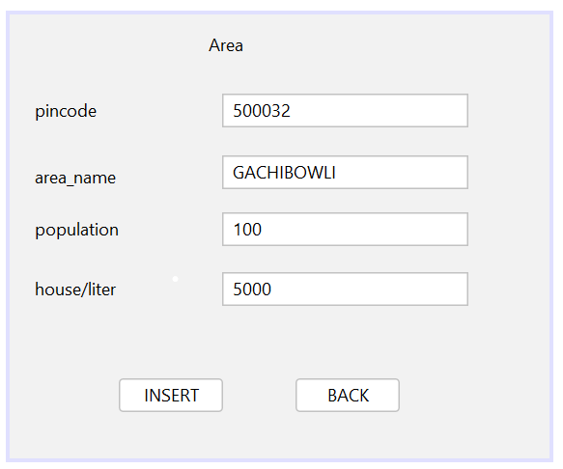

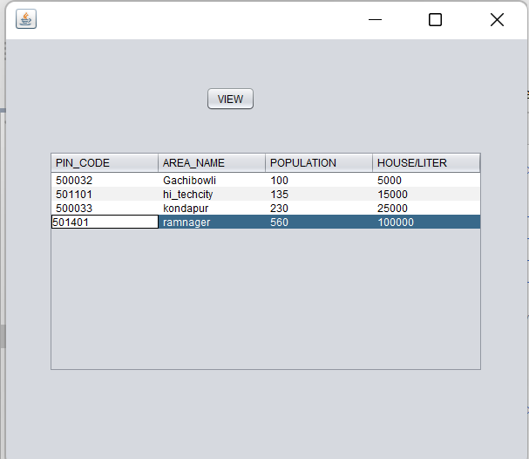

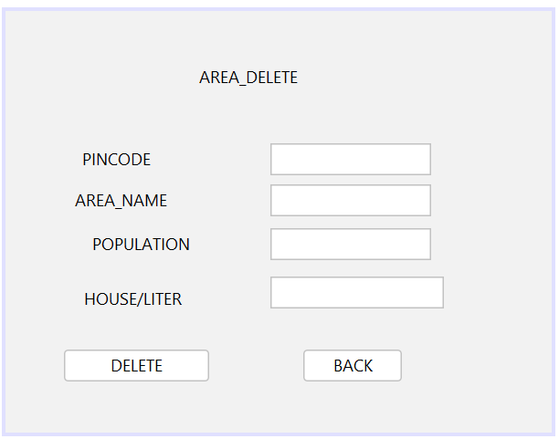

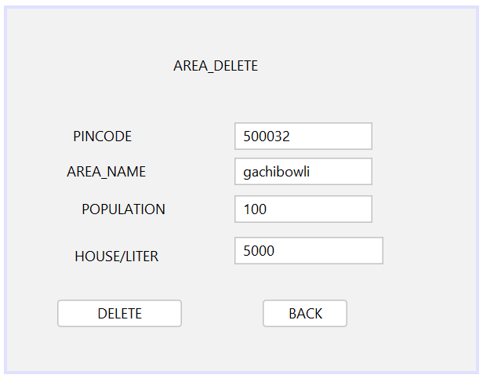

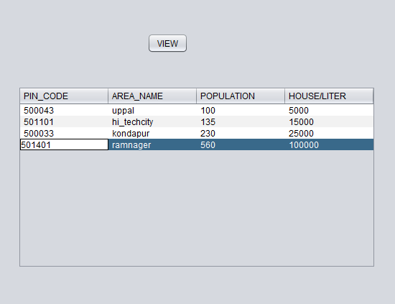

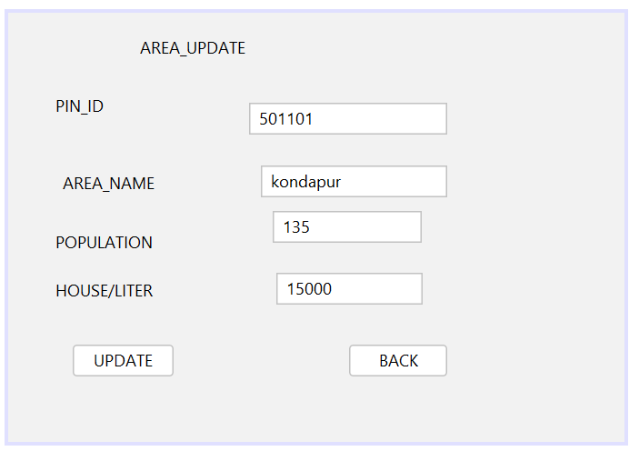

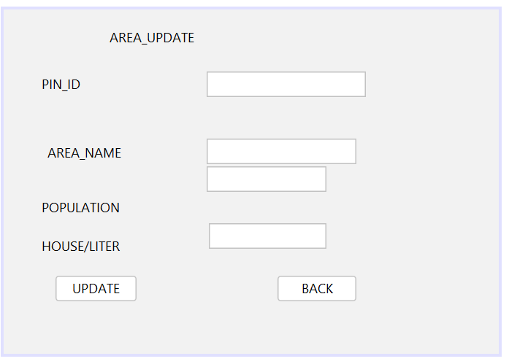

**RESULT:**

**I successfully completed this MINI PROJECT “H20 TRACKER “.**

Discussion and Future work

While doing this project I got new ideas I understood how to work on projects. Now to further extend this project I want to create a android app by which I can control my project on my hand and connect to it.

REFERENCES:

